Start-up **iFix**.

**Vision.**

The vision of our start-up development is to learn for further investment in our product, which is business model for software development. By applying the expert design thinking through the development phases, we want to learn about software technical and behavioral issues and user activities. It starts with explaining the main scenario, then deconstructing it in sub-scenarios to be implemented individually. The vision goal is to deal with emergence problem type to provide avoidance of problem through the measurements.

**Mission.**

Mission is starting the implementation of business model with building the product by involving the right team and the work with right Life cycle technic to produce prototype. To learn from this prototype by the measurement technics (technical and behavioral) to fulfill our investment goal.

**Team:**

Project Manager – Nazar Zhanabergenov

Software Developer – Ravshanbek Musaev

Software Designer – Kateryna Sadovska

**Problem.**

We want to invest in car industry and open a car dealership with a service center. From the development we want to learn about our customers, their preferences, cars, problems and to get all the necessary data which we would be able to apply in future. We need data to have better understanding of our customers and their cars to provide outstanding service. To be able to implement our idea, we need to build an application.

**Solution.**

In the application we are going to develop, car owners can register themselves and their car, as well as all the technical data of the car. In case of any problem with the vehicle, the functionality of our application will help the user find the most convenient car service. In addition, our application will have a customer base where the user, if desired, will be able to buy a new or used car, or sell his own. In line with all the functionality and convenience for the user, in our application will be set all necessary measurements to provide us with data, so we can achieve the vision of the development.

**Business Model.**

* Idea and Vision.
* Gather Team.
* Business Plan.
* Build an application following V&V Lifecycle Model – Feasibility study, Requirements Analysis and Definition, Software Design (considering Metrics that we will measure), Testing. Verification and Validation occurring after each phase of Build to ensure that development is going in right way.
* Measure. Collect behavioral and technical data.
* Release prototype. The prototype will be already working model of the development with metrics. It will allow developers measure technical data and fix any occurring errors, and to collect behavioral data about users of the application.
* 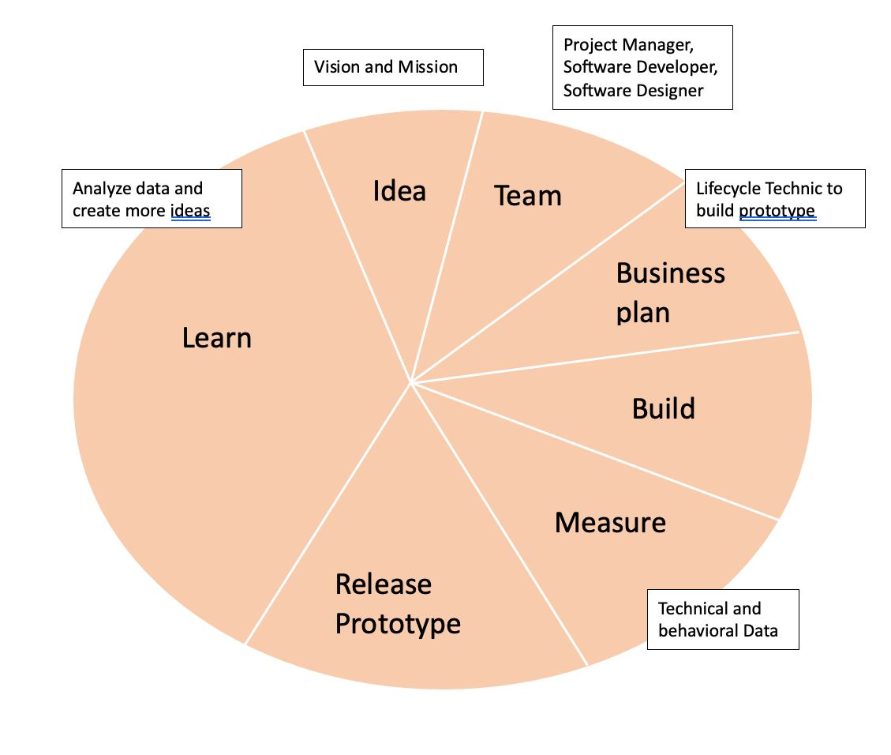Learn – analyze the data.

Enforcing the Business Model through the Verification and Validation.

To perform the Verification and Validation, we set the standard rules for each step of the Business Model.

1. Clearly define the Vision and Mission of the start-up development.
2. Gather the team according to the roles.
3. Propose the Business Plan, define what Lifecycle Technic to use to build the Prototype.
4. Build the application following the Lifecycle Technic:

* Feasibility Study. Output – tables of users and activities.
* Requirements Analysis. Output – mapping of users and activities.
* Requirements Definition. Output – functional and non-functional requirements.
* Software Design. Output – design of application according to functional and non-functional requirements and consider Metrics that we will measure.
* Software development. Output – build the prototype based on output of Software Design and Requirements Definition.
* Testing. Output – report of testing the prototype.

1. Measure. Set all necessary metrics and parameters, measure them.
2. Release Prototype. Start measure and collect data.
3. Learn. Analyze the acquired data for future use.

**Idea.**

We develop an application to help our users solving their car problems, direct to the nearest service centers. Also, we provide platform for buying and selling cars.

For the development we will collect data: user’s age, gender, geolocation, health condition. About car: manufacturer, model, production year, mileage, color, insurance, incidents history, all data about technical condition, number of drivers, if pets were in car. Technical data as visibility, connection, availability, accessibility, security, delays, downtime, performance, errors will be necessary to improve and maintain the application.

After this we will have enough insight knowledge to open our own car dealership with a service center and improve the application. Also, we will sell the Data to car manufacturers, car insurance companies, other car dealerships, service centers, car rental companies and taxi services. By collecting data, we will be able to provide our customers with the best quality service.

**Feasibility Study.**

Users: users with car, users without car, admin.

Activities: login, sign up, fill in application, add car data, edit car data, delete car data, edit profile, search for problem, pin, notifications, problems history, map of service centers, view car offers, buy car, sell car, car search, filters, wish list, search history, viewed cars history, p2p chat. For admin – edit problems list, add service center, edit service centers information, delete service center, post important information, send notifications, view metrics, access database.

**USERS**

**ACTIVITIES**

Sign up

Login

Buy car

Sell car

Fill in application

Add car data

Edit car data

Delete car data

Edit profile

Search for problem

Receive notifications

Problems history

Map of service centers

View car offers

Car search

Filters

Wish list

Search history

Viewed cars history

P2P chat

Edit problems list

Add service center

Edit service centers information

Delete service center

Post important information

Send notifications

View metrics

Access database

Car owners

Users without car

Admin

**Requirements analysis.**

Mapping. Using the output from Feasibility Study we were able to construct the mapping diagram for Users and Activities.

**ACTIVITIES**

Sign up

Login

Buy car

Sell car

Fill in application

Add car data

Edit car data

Delete car data

Edit profile

Search for problem

Receive notifications

Problems history

Map of service centers

View car offers

Car search

Filters

Wish list

Search history

Viewed cars history

P2P chat

Edit problems list

Add service center

Edit service centers information

Delete service center

Post important information

Send notifications

View metrics

Access database

**USERS**

Users with car

Users without car

Admin

**Requirements definition.**

Functional and non-functional requirements.

*Login*.

Functional: Email and password fields, sign in button, “Forget Password” button, “Create an account” button.

Non-Functional: Accessibility to database, read from database, verification, validation, security, connection, visibility, error handling, redirect.

*Sign up.*

Functional: Username, password, repeat password, email, application form (first name, second name, gender, date of birth, country, city, address, phone number, special health condition), car information (optional).

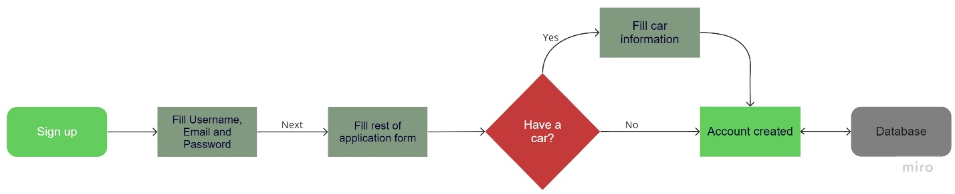Non-functional: Accessibility to database, write to database, security, password encryption, connection, visibility.

*Main.*

Functional: Cars, repair, latest cars listing, main, chat, profile, notifications.

Non-Functional:

* Cars and Repair – redirect, connection, database, visibility
* Latest cars listing – database, update state, visibility, redirect
* Chat – redirect, verification, database, connection, security
* Profile – redirect, verification, database
* Notifications - redirect, update state, visibility

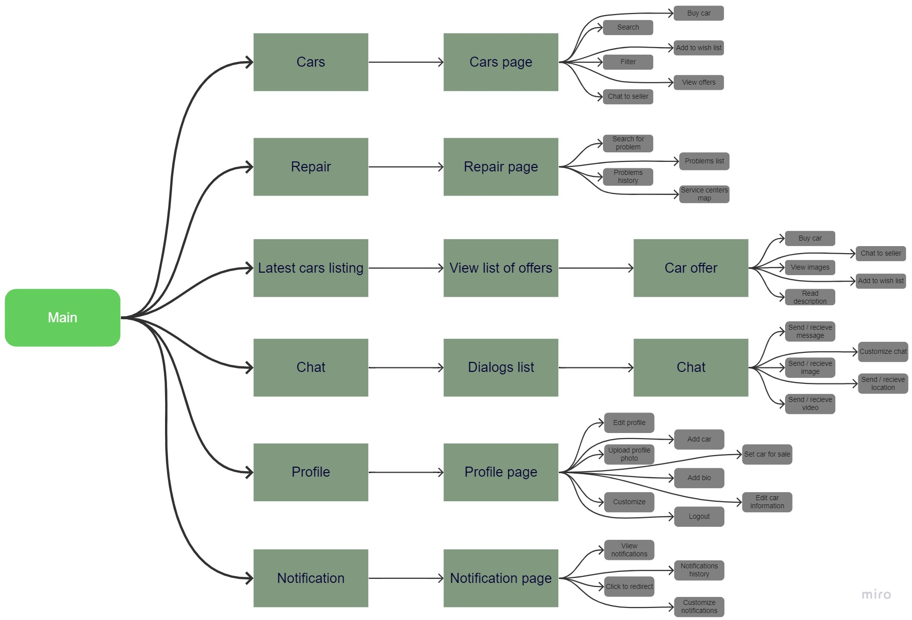

*Cars.*

Functional: Car listings, search and filter, car comparison, user reviews and ratings, price, car information.

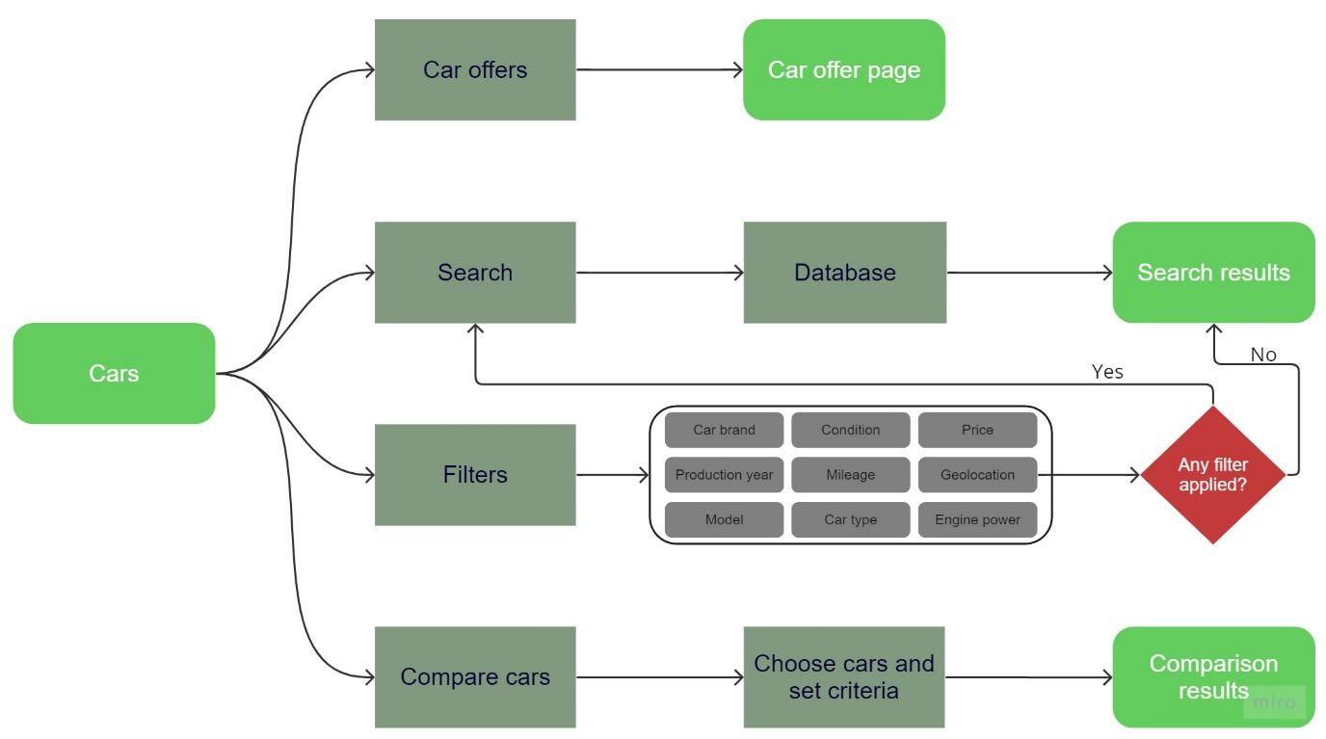Non-Functional: Security, user-friendly interface, scalability, error handling, database, visibility, update state.

*Car offer.*

Functional: Car images, detailed car information (brand, model, year, mileage, condition, seller’s comment, price), seller’s rating, chat, buy car, add to wish list.

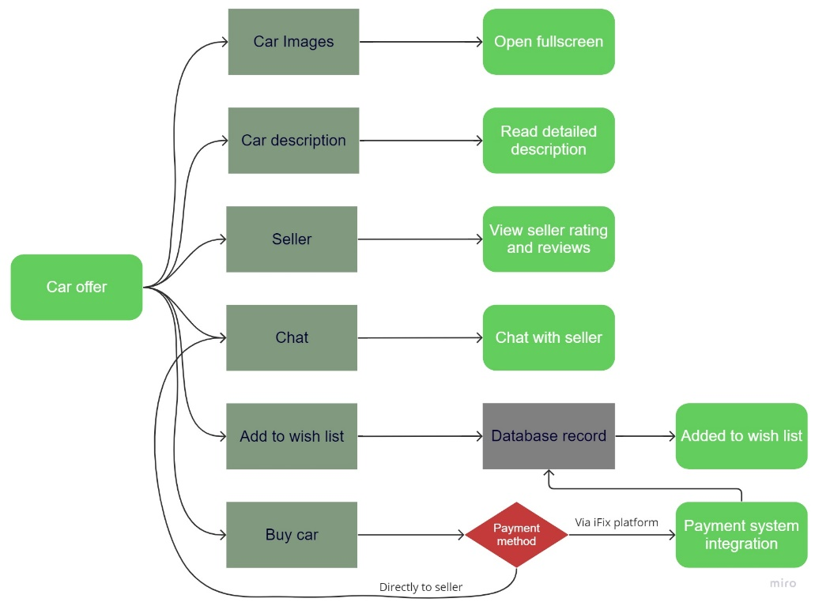Non-Functional: Database, security, visibility, verification, connection, availability, encryption, payment systems integration.

*Repair.*

Functional: Type of problems listing with icons, search, service centers map with location-based service recommendations, service provider contact, service reviews and rating, service descriptions and pricing, appointment scheduling.

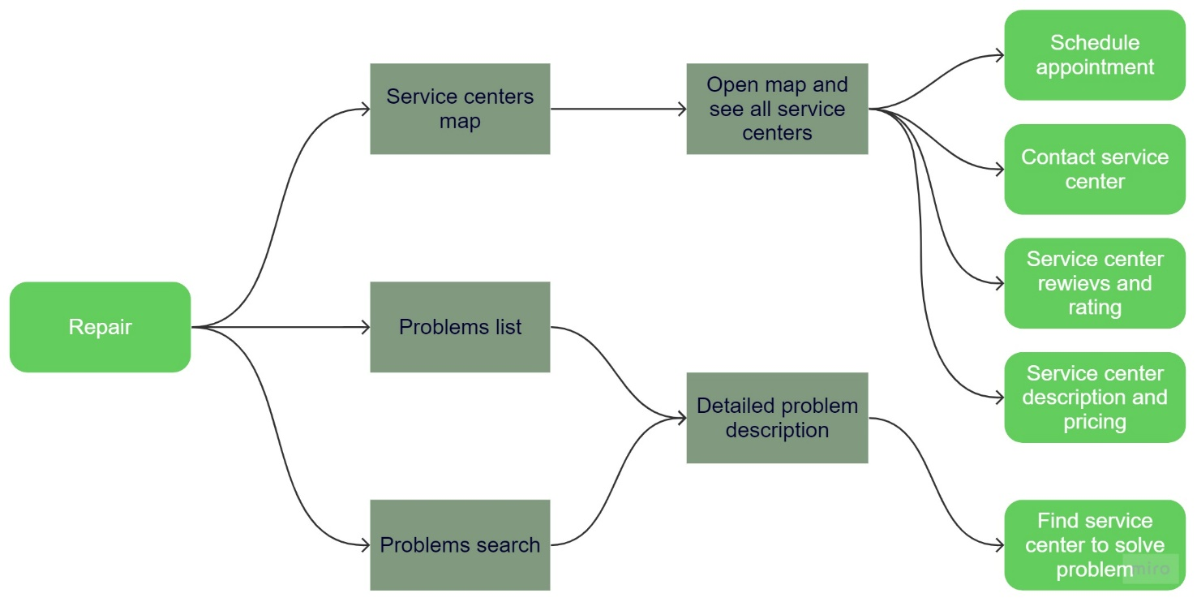Non-Functional: Performance, Security, user-friendly interface, scalability, error handling, constant update, database, Service Quality Assurance, Data Privacy, Integration with current geolocation, availability, response time.

*Latest cars listing.*

Functional: List of latest car offers, car information (model, year, specifications, features, price) and images, filters, sort by latest or oldest, contact seller, save to wish list.

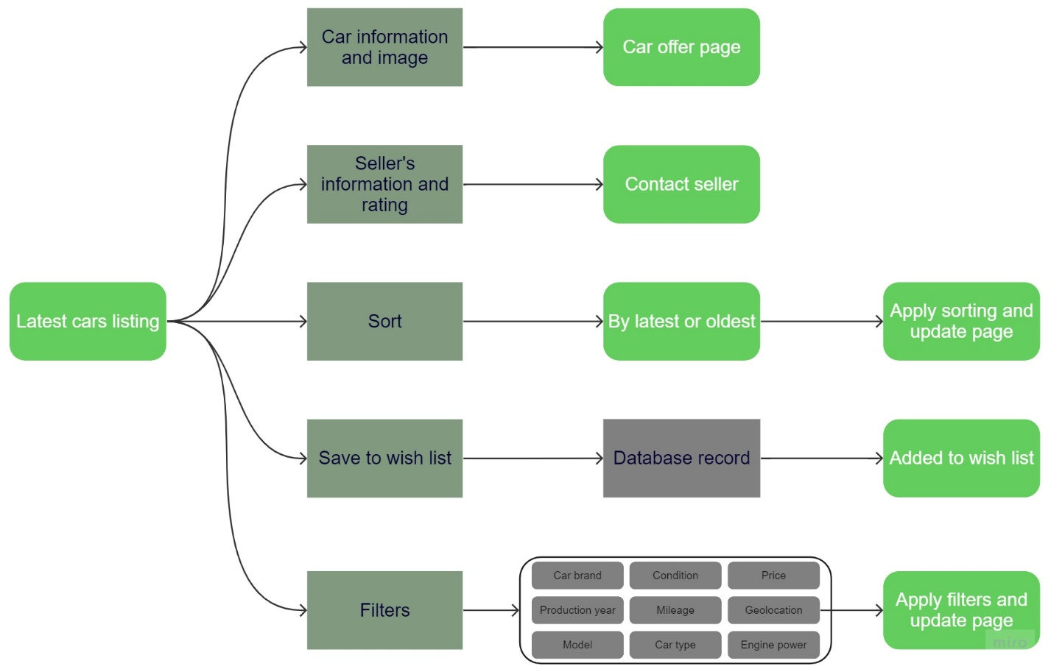Non-Functional: Security (secure connection, data protection), redirect, database, mobile adaptation, search and filter efficiency (using keywords), error handling, integration with payment systems, constant list update.

*Chat.*

Functional: Real-time messaging, user authentication, message sending and receiving, emoji and GIF support, typing indicators, message history, message editing, share (image, video, file, location), notification alerts.

Non-Functional: Security (secure connection, data encryption), user-friendly interface, mobile responsiveness, scalability, error handling, chat history storage, data privacy, network connection, database.

*Profile.*

Functional: User logout, profile picture upload, edit personal information (e.g., name, email, contact details), bio or about me section, wish list, profile customization options (e.g., theme, layout), add car, edit car information, set car for sale.

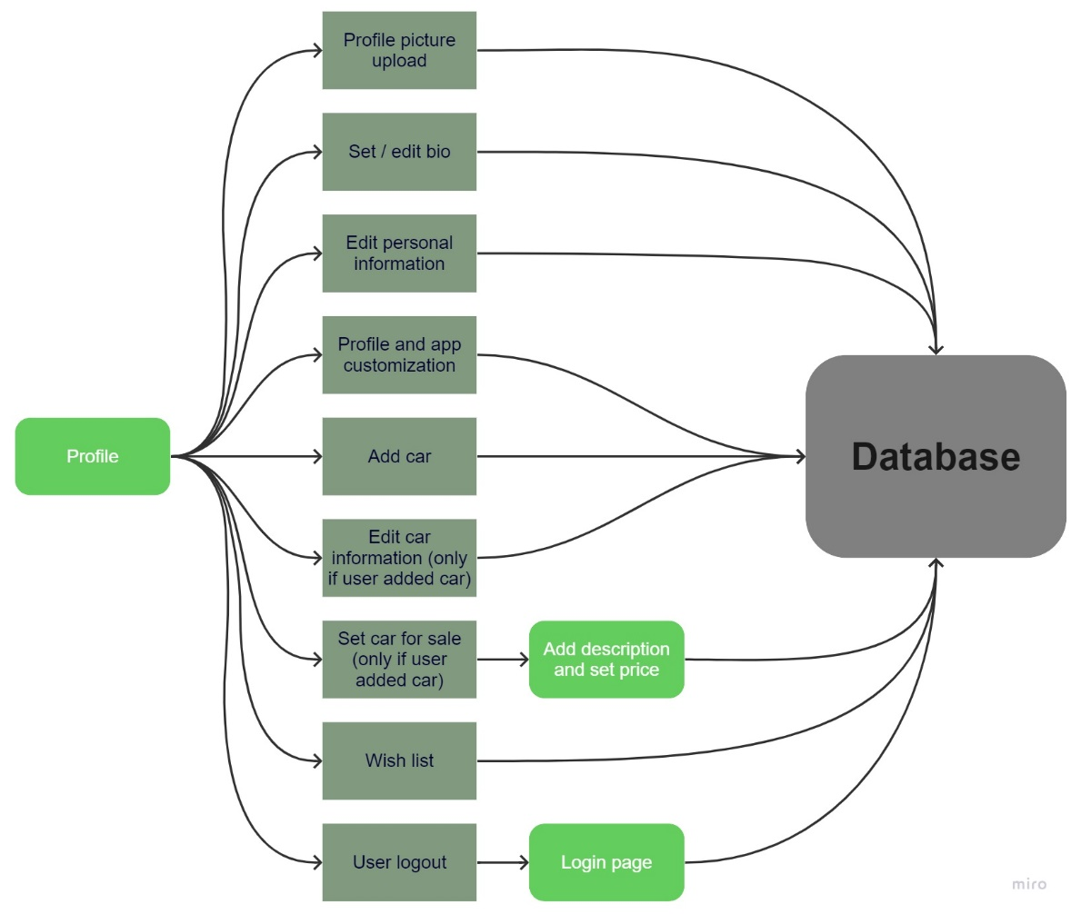Non-Functional: Performance, security (secure connection, data protection), mobile responsiveness, scalability, error handling, data privacy, integration with authentication systems, database accessibility, database read and write.

*Notifications.*

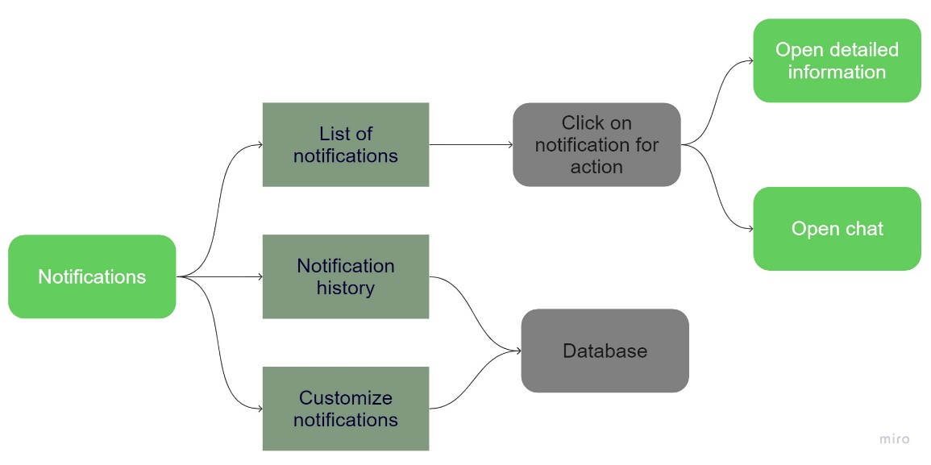Functional: Notification display, real-time notifications, clickable notifications for action, notifications history, in-app and push notifications, customizable notification types (e.g., messages, friend requests, updates).

Non-Functional: Security, data protection, mobile responsiveness, error handling, real-time notification delivery, storage in database, privacy and consent management, cross-platform compatibility (Web, Mobile, Desktop)

*Buy a car.*

Functional: Purchase way: 1) directly from seller – chat; 2) through our platform – choose payment method, pay.

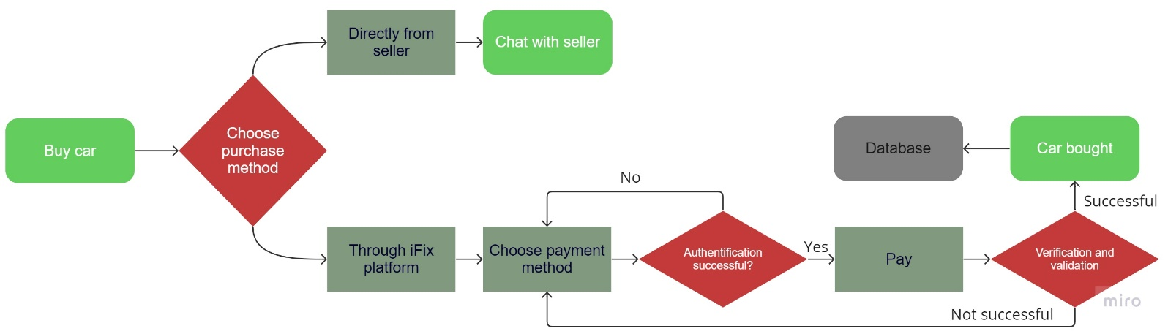Non-functional: Security, data protection, encryption, redirect, database record, payment systems integration, verification and validation, connection, visibility.

*Sell a car.*

Functional: choose car to sell, add detailed description with car parameters, add images, set price, set for sale.

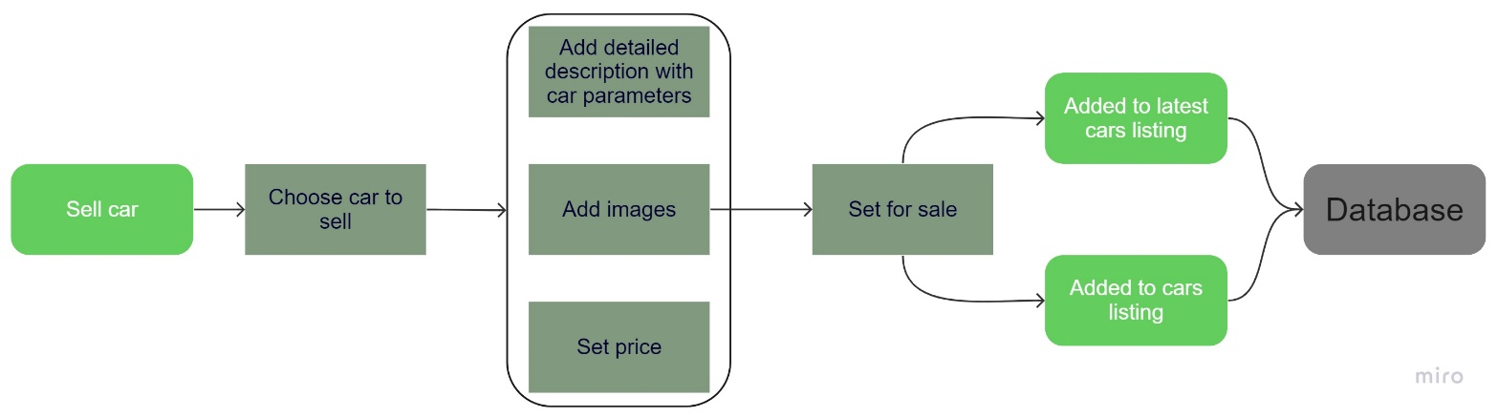Non-functional: Verification, database record, security, data protection, car listings update, connection, visibility.

**Measurement.**

|  |  |  |
| --- | --- | --- |
| **ACTIVITIES** | **METRICS** | **PARAMETERS** |
| Login | response time, authentication, connection with database, visibility, session start time, session end time | user ID, number of users, user’s number of logins per day, session duration |
| Sign up | response time, verification, availability, visibility, database efficiency check, correctness of database “create record”, security | user ID, email, username, number of signups (new users) per day |
| Fill in application | database efficiency check, connection | user’s first name, last name, gender, age, country, city, address, phone number, special health condition, car info (optional) |
| Add car data | correctness of database “create record” and “write” | car brand, model, year, type, mileage, condition, color, accidents history, problems, insurance, pet in the car, number of drivers |
| Edit car data | connection with database, visibility, error handling, correctness of database “edit record” | frequency of car data edits, last oil change, last filter change, etc |
| Delete car data | correctness of data base “delete record” | number of users deleting cars, most deleted cars |
| Edit profile | correctness of database “edit record” | which data users edit the most, frequency of edits |
| Search for problem | keywords, correctness of database “read”, visibility | keywords, frequency, user ID, most searched problems, problem – car brand/ model/ type/ mileage correlation, problem – user age/ gender/ country/ city correlation, problems – location correlation, car age – problems frequency correlation |
| Problems history | data storage check, connection to database, visibility |
| Notifications | notifications delivery check, connection | most opened notification type, notifications check frequency |
| Map of service centers | GPS connection correctness, network stability | user ID , current geolocation, most visited locations, service centers availability, frequency of map using, most visited service centers |
| View car offers | session start and end, database stability check, correctness of database “read”, update state check, availability | most popular: car brand, car type, car model, car color, car year, car mileage, price range, sellers; offer view duration, time of session and when session start and end, gender and age of users who view the most, view – buy ratio |
| Buy car | database connection, security, encryption correctness | most buying: car brand, car type, car model, car color, car year, car mileage, price range; view – buy ratio, user ID, gender and age of users who buy the most, type of users who buy the most, most popular payment method |
| Sell car | start and end of offer time, availability, database check | most selling: car brand, car type, car model, car color, car year, car mileage, price range; how fast car is sold, gender and age of users who sell the most; country, city, location where most of cars sold |
| Car search | keywords, correctness of database “read”, visibility, search speed | user ID , keywords, frequency, duration, which time search the most, most searched: car brand, car type, car model, car color, car year, car mileage, price range; type, age, gender, location of users who search the most |
| Filters | database response, correctness of filters applications | most used filters, frequency of filters usage |
| Wish list | items limit, database connection and visibility | user ID, most added to wish list: car brand, car type, car model, car color, car year, car mileage, price range; ratio of cars bought from wish list |
| Search history | keywords, correctness of database “read”, visibility, database connection | user ID, keywords, frequency, most searched: car brand, car type, car model, car color, car year, car mileage, price range |
| P2P chat | connection, response time, correctness of message and data share | session duration, frequency, with who user chats the most, sellers that get most messages, amount of files shared |

**Learn.**

*For our own investment.*

What. User’s age, gender, country, city, address, most visited places, users who own cars locations, most popular services, most searched problems, most searched and buying car brand, car type, car model, car color, car year, car mileage, price range, sellers, view – buy ratio, most added to wish list, most deleted cars.

For what. All these data will help us to decide where to open our car dealership with service center, which cars are in most demand to sell them, which cars to avoid selling (not reliable / not liked by users) and which services are most popular, so we provide them.

What. Number of users, user’s number of logins per day, session duration, number of signups (new users) per day, notifications check frequency, search frequency, search duration, which time search the most, chat session duration, chat usage frequency.

For what. Using this data, we will be able to identify the trend (number of users increasing or decreasing), demand on our application, frequency and duration of application usage.

What. All technical data: response time, connection with database, visibility, session start time, session end time, availability, connection, database efficiency check, correctness of database “create record”, correctness of database “edit record”, correctness of database “delete record”, security, error handling, keywords, correctness of database “read” and “write”, data storage check, notifications delivery check, GPS connection correctness, network stability, update state check, search speed, database response, correctness of filters applications, wish list items limit, correctness of message and data share.

For what. This data is very important for errors correction, maintenance of our software development, its further scalability and improvement of the quality.

*For car manufacturers.*

What. Most searched problems, problem – car model/ type/ mileage correlation, problems – location correlation, car age – problems frequency correlation, most buying: car type, car model, car color, car year, car mileage, price range.

For what. Using this data car manufacturers can easily identify which car models are in most demand and best-selling. Also, they will get valuable real-life data on exploitation of their cars, which car models face particular problems. So, manufacturers will be able to fix these issues while building cars.

*For insurance companies.*

What. User’s gender, age, country, city, address, special health condition, accidents history, pet in the car, number of drivers, problem – car brand/ model/ type/ mileage correlation, problem – user age/ gender/ country/ city correlation, problems – location correlation, car age – problems frequency correlation.

For what. Using this data, insurance companies would be able to identify the car models, car owner types, locations which have / cause the most problems with cars. So, by applying knowledge from data, they will set insurance prices more precisely.

*For car dealerships.*

What. Most popular and buying: car brand, car type, car model, car color, car year, car mileage, price range; view – buy ratio, problem – car brand/ model/ type/ mileage correlation, car – user age/ gender/ country/ city correlation, problems – location correlation, car age – problems frequency correlation.

For what. With help of this data, car dealerships will be able to identify the most popular and buying cars for particular regions and customer’s type. Also, they will know which cars to avoid selling in the dealership due to huge number of problems occurring to that car models.

*For service centers.*

What. User’s gender, age, country, city, address, most visited locations, frequency of map using, most visited service centers, most searched problems, problem – car brand/ model/ type/ mileage correlation, problem – user age/ gender/ country/ city correlation, problems – location correlation, car age – problems frequency correlation, most popular service.

For what. By analyzing and applying knowledge from this data, service centers will be able to: find the best and in-demand place for new service center, which services are most popular in particular area and customer’s type, what are the typical and most frequent problems with particular car brands/ models.

*For car rental companies.*

What. User’s gender, age, country, city, address, most popular: car brand, car type, car model, car color, car year, problem – car brand/ model/ type/ mileage correlation, car age – problems frequency correlation.

For what. Using this data car rental companies will know which car brands / models are most and least reliable, which cars clients like the most. So, they will know what cars to acquire to their rental saloons for maximum profit and customers satisfaction.

*For taxi services.*

What. Car brand, car type, car model, car color, car year, problem – car brand/ model/ type/ mileage correlation, car age – problems frequency correlation.

For what. The best cars for taxi services are those which are the most reliable and cause minimum problems. With this data taxi services will have the information about the most and least reliable cars, what are the typical and most occurring problems for particular car brand / model. So, they will be able to fill their taxi park with most suitable cars and avoid not reliable ones.